Living Lab
LL

Sciences| September 2019

Water Quality (Bacterial Source Tracking) Protocol

Background:

What are coliform bacteria?
Bacteria are a wide group of unicellular organisms that have cell walls, but lack other characteristics of other cells (like organelles and having an organized nucleus). Most bacteria are harmless, but some can cause diseases. Coliform bacteria are a type of bacteria that exist naturally in all warm-blooded animals, and also in the natural environment (such as in rivers and soil). While most coliform bacteria are harmless, some (including E. coli) can cause problems for humans and wildlife if consumed.

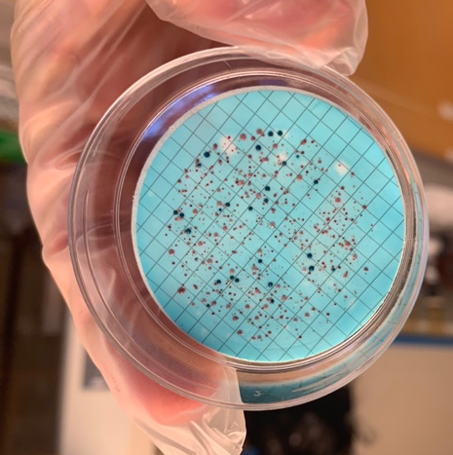
Figure 1. Cultured coliform bacteria colonies, prepared from water samples! E. coli colonies are dyed blue from the staining process, while all other coliform bacteria are shown in red.

What is E. coli bacteria?
E. coli is one species of coliform bacteria that is found in warm-blooded animals, and is potentially harmful to humans if ingested. While it is found in many ecosystems naturally through transmitters like animal feces and decay, a waterway can become contaminated with E. coli if quantities reach a dangerous threshold. E. coli can also stay in many animals used for food such as shellfish, causing problems for food harvest in contaminated areas.

The Mission
Today, we are going to test how much E. coli is in our waterway and compare any E. coli found to Canadian health guideline standards.

During Water Sample Collection:
- Collect samples in sealed containers from desired water source.
- When collecting the sample, try not to stir up any sediment or particles in the area where you are collecting. This will help prevent contamination in your water sample.
- After collection, store your water sample in a cooler with temperatures below 4C, but do not freeze.

Day 1 (Lab): Preparing our samples.

1. Put on sterilized gloves and wipe down the lab countertop with ethanol. Rinse the vacuum funnels twice with distilled H2O. Turn on the incubator and set it for 37.0C.

2. Retrieve water samples from cooler. Initiate membrane filtration as soon as possible to minimize changes in the water sample.

3. Take out a petri dish and mark the lid with information about your sample (collection area, filtration date, your name, and any other necessary information).

4. Unwrap two sterilized membrane packages. Using sterilized forceps, place the white absorbent pad into the petri dish. Place the membrane, grid-side up, on the magnetic funnel base.

5. Retrieve an mCOLI-Blue ampule from the cooler. Twist off the top to open and squeeze the ampule contents on to the absorbent pad. Be sure to spread the blue liquid as evenly as possible on the pad. Replace the lid of the petri dish.
How does mCOLI-Blue Work?
The serum mCOLI-Blue is used to help us tell how much E. coli bacteria we have in our sample, versus other (less hazardous) types of bacteria. It does this by colouring all E. Coli in a sample Blue, while colouring all other types of bacteria in the sample Red!

mCOLI-Blue can do this because the molecular structure of E. Coli is different from other forms of bacteria. mCOLI-Blue recognizes these differences in structure by using what is called an enzymatic indicator, which attaches a blue dye using an enzyme to E. Coli and attaches a red dye to other types of bacteria! Pretty cool, huh?

6. Shake sample bottles well and filter 100mL of water through the filter under vacuum. Vacuum should be left on until all water is drained through the membrane.

7. Using sterilized forceps, carefully peel the grid membrane off of the filter, and place it grid side up on the absorbent pad, using a slight rolling motion. Check for air trapped under the filter and make sure the filter touches the entire pad. Replace the lid of the petri dish.

8. Invert the petri dish, and set it into the incubator. Incubate the plate(s) at 37C for 24 hours.

9. Rinse the filters with dH2O, and then again with 70% ethanol. Dispose of the membrane and ampule packaging, and wipe down your workspace with ethanol.

Day 2. Count and Calculate!

9. Remove the petri dish from the incubator. If you cannot examine the plates immediately after incubation, store the plate(s) at 4C.

10. Examine the filters (grid membranes) for colony growth. Colonies are usually visible to the naked eye, however a 10-15X magnifier or microscope is recommended. Red and blue colonies indicate total coliforms and blue colonies specifically indicate E. coli. How many E. Coli colonies do you see?

11. It’s time to calculate the total E. Coli in our sample! All water health guidelines in Canada are made by calculating the total number of E. Coli colonies in a 100mL sample. So, can figure out how healthy our water is by using the following formula:
Calculating total E. Coli:

Coliform colonies (per 100mL) = $\frac{Sum of colonies in all samples}{Sum of volumes \left(in mL\right) in all samples}$ x 100

12. What does your calculation tell us about how we can use this water?
Did you know?
In order for fresh water to be drinkable, Canadian health guidelines say that there must be no E. Coli present in a 100mL sample! But, even if there is some E. Coli present, that doesn’t mean the water isn’t usable for other activities! Compare your findings to the list below, and see what Canadian Health Guidelines recommends is safe to do with your water sample:

Water Use | Maximum E. Coli / 100mL
Drinking water | 0 colonies
Recreational use | 200 colonies
Harvesting shellfish | 14 colonies (DFO, 2019)

13. Enter the sample information, including red and blue colony counts, into the lab log book. With a smartphone, take a picture of your findings, and send them to rimmertalen@gmail.com.

Why is this important?

Knowing what’s in our water matters, and not only in order to drink it! People have been reliant on harvesting seafood from beaches since time immemorial. In coastal British Columbia, these delicacies include traditional foods such as Pacific Oysters, Butter Clams, sea urchins, and many other intertidal species! If too much E. Coli accumulates in a waterway without treatment, however, it can make its way into both the ocean and these sea critters, affecting their health and making them inedible. By figuring out how much E. Coli is in your sample right now, you’re helping to make sure that important creatures like these can continue to thrive and play an important role in our ecosystems.

Next Steps:

Now that you know how much E. Coli is in your sample, you’ve successfully helped to monitor the health of your sampled waterway! There are actually lots of other ways that you can look at water health, and other measures that can tell us even more about the ecosystem.

For example, when you were taking your water sample, did you notice any green film or colouration in the water? If you did, it may be that there is too much algae growing in the waterway, which can prevent other important creatures (like fish) from thriving. To test this, we can look at something called the chlorophyll in our water. Chlorophyll is a green pigment given off by plants and algae. By testing chlorophyll, we can figure out just how much algae is in our water, and see if its healthy or needs restoration.

This protocol is adapted from the protocol of Dr. Gerard Berdie & Joyce Sun, Water & Aquatic Sciences Research Program, University of Victoria. Last Updated 30 Sept, 2019.

